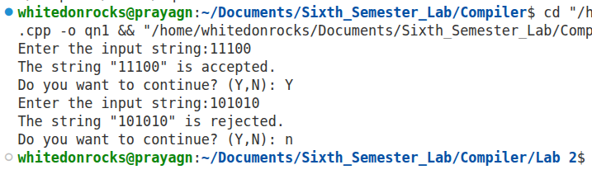
OUTPUT:

OUTPUT
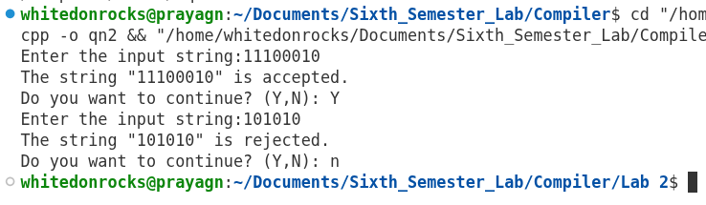

OUTPUT
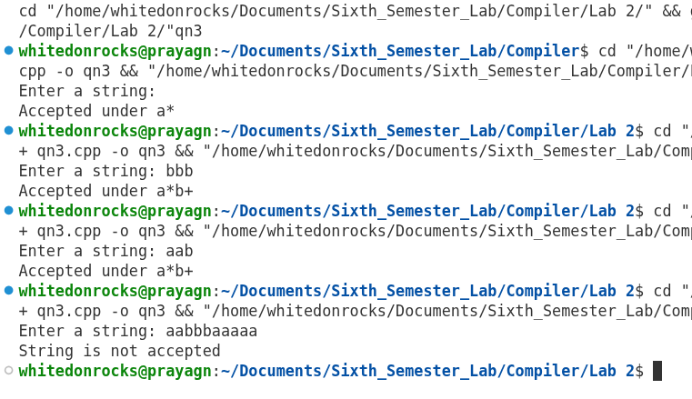

OUTPUT
